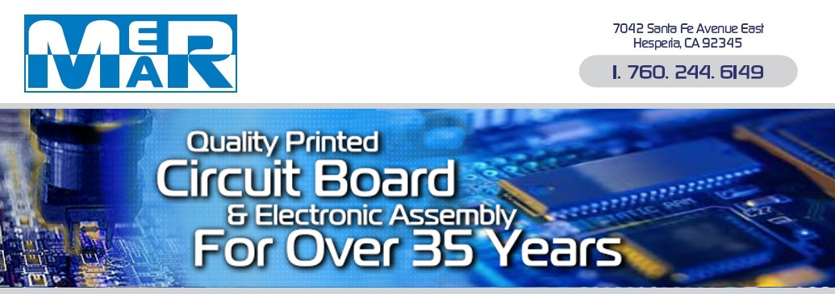

Mer-Mar, Inc.
Conflict Minerals Statement

Mer-Mar, Inc. fully supports the position of the Electronic Industry Citizenship Coalition (EICC) and the global e-Sustainability Initiative (GeSi) in avoiding the use of conflict minerals which directly or indirectly finance or benefit armed groups in the Democratic Republic of Congo (DRC) or adjoining countries.

Silver, tin, gold, and tantalum are used in the manufacturing of components that are used in the fabrication of bare boards, capacitors, connectors, and solder and other components that Mer-Mar obtains for customer assemblies. Most of our suppliers have provided written statements, or have posted statements on their web sites, confirming they do not receive minerals for manufacturing their components from the DRC or adjoining countries. For those that do not have public statements, we will ask them to provide statements that confirm compliance.

Mer-Mar, Inc. will terminate business with any supplier if we determine that the supplier is directly or indirectly not in compliance.

David Graham
Quality Assurance Manager
Mer-Mar, Inc.

Mer-Mar Conflict Minerals Statement, revision A.

